**Satellite SO-124 FM Repeater Now Active**

February 25, 2025

[AMSAT has designated](https://www.amsat.org/ans-054-amsat-news-service-weekly-bulletins/) the recently launched HADES-R as Spain-OSCAR 124 (SO-124). The satellite features an FM repeater and is now open for amateur radio use. The upload frequency is 145.925 MHz and the downlink frequency is 436.885 MHz. SO-124 also supports APRS and FSK telemetry.

[**Field Spotter**](https://t.e2ma.net/click/fuxk1m/rbzqkzte/ngk714)  
A spotting tool for portable Amateur Radio adventures.

<https://fieldspotter.radio/?utm_source=amateur-radio-weekly&utm_medium=email&utm_campaign=newsletter>

**Radio Connects is 2025 ARRL Field Day Theme**

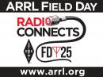

*03/14/2025*

ARRL The National Association for Amateur Radio® has released the logo and theme for this year’s [ARRL Field Day](https://www.arrl.org/field-day), June 28 – 29, 2025.

The theme for 2025 Field Day is “Radio Connects” — highlighting the many ways that wireless technology connects people across distances near and far. The event is part picnic, campout, practice for emergencies, informal contest, and most of all, fun! ARRL Field Day is the most popular ham radio activity held annually in the US and Canada. On the fourth weekend in June each year, more than 31,000 hams get together with their radio clubs, schools, or friends to operate from remote locations.

[What Can We Do to Get Youth into Ham Radio?](https://www.onallbands.com/what-can-we-do-to-get-youth-into-ham-radio/)

Posted by [Katie Campbell, KE8LQR](https://www.onallbands.com/author/katie-campbell-ke8lqr/) on March 19, 2025 at 12:51 pm

Aside from encouraging me to study for my Technician exam (and the other two exams…now that I look back on it) my parents really didn’t have to work very hard to convince me to become involved with amateur radio. In fact, it was the other way around. After going to a Skywarn meeting and asking for the “ham sign-in” and the “non-ham sign-in” sheets, my father decided it was probably time to get his license. (He now has his General class and is studying for his Extra with my younger sister.)

My father isn’t the only member of my family I talked into getting an amateur radio license, though. Both of my younger sisters have taken interest in the hobby, although convincing them that getting their licenses would be worth it was significantly more challenging than it was for my father. Both of them getting their licenses at nine years old posed some unique situations (anybody know how to teach Ohm’s Law to someone who hasn’t taken an algebra course yet?). But after having had the experiences of getting my two younger sisters involved and getting licenses (as well as a few other kids from my school’s amateur radio club), getting young people into amateur radio is almost second nature to me now.

While the selling points and approaches that ultimately spark interest in a young person will be different for each individual, there are a few constants that I’ve noticed in the process:

**Encourage but don’t force them**. No young person wants to be told that they have to do something—truthfully, that is the fastest way to dissuade them from picking up the hobby. Instead of lecturing them or trying to force them to become involved, help them find what interests them in amateur radio. From CW to digital modes, SSB rag-chewing to antenna building, the hobby really has something for everyone. As soon as kids find what motivates them to be involved in the hobby, they’ll start studying for the exam.

**Utilize as many hands-on demos and activities as possible!** The opportunities in amateur radio are endless. It could be something as simple as putting together a basic parallel or series circuit that merely lights up an LED, or something more complex (building and designing an antenna perhaps), depending on the skill level of the young person and their time commitment.

These demos and activities don’t have to be centered around building things either. [**Fox hunts**](https://www.onallbands.com/fox-hunting-getting-young-people-hooked-on-the-adventure-of-ham-radio/) are always a hit with the kids in my school club, particularly the younger members. It’s always entertaining when the adults try to explain to the kids that the transmitter they’re looking for looks like a film canister, then realize that none of the 9- to 18-year-old club members even know what a film canister looks like.

**Making a few CW contacts** and explaining/translating what information is being exchanged is also a fun way to demonstrate what you can do with amateur radio, particularly because Morse code has a sort of “secret language” appeal to it for young people who find the thought of learning a language that their parents don’t know fascinating.

If the young person or group is a bit mic shy, **digital modes are always a great option**. They showcase some of the more technology-heavy aspects of the hobby; young people find the dichotomy of the hobby being “wireless” but also digitally intertwined fascinating.

**Contests are another good option** for getting young people interested due to their fast-paced nature and the camaraderie that accompanies a multi-operator effort.

All of these things considered, remember that you are simply a resource for the kids, and one of many at that.

Finally, **showing kids that there are other young people in amateur radio** is by far the most effective way to get them interested. There are numerous avenues in which to do this. Two excellent ones are the [**Young Amateur Communications Ham Team (YACHT)**](https://qsl.net/yacht-arc/home.html) and their nets, and groups like [**Youngsters On The Air (YOTA)**](https://www.ham-yota.com/). For example, YOTA sets up booths at many of the larger Hamfests in the U.S., serving as a meeting place for young people and providing an opportunity to find a group of encouraging young hams.

Getting young people interested in amateur radio is far from easy, especially in today’s world where youth have infinite resources at their fingertips. By acting as a resource and simply showing kids what they could do with amateur radio, you can make it more relevant and be able to develop a more successful approach to getting young people interested and involved in this amazing hobby.

**Fram2 Makes First Amateur Radio Contact from a SpaceX Spacecraft**

April 2, 2025

The [Fram2](https://f2.com/) mission successfully launched from the east coast of the US via a SpaceX rocket late Monday evening. Just a few hours later around 9:30 AM Berlin time, Rabea Rogg (LB9NJ) became the first astronaut and amateur radio operator to make contact with Earth from a SpaceX Dragon spacecraft. Rogg is also the [first woman from Germany in space](https://bsky.app/profile/tuberlin.bsky.social/post/3llqm3quxes2c). Contact was made between Rogg and the [DK0TU amateur radio club](https://www.dk0tu.de/) at the [Technical university of Berlin](https://www.tu.berlin/).

The amateur radio contact is significant as the International Space Station (ISS) faces a decommissioning date within the next 5 years. ISS has been the primary source of amateur radio voice contacts from astronauts since the NASA Space Shuttle program was sunset in 2011. Fram2 has demonstrated that SpaceX may be a viable alternative for space based amateur radio QSOs with astronauts beyond the ISS's lifespan.

In addition to voice contact with the university, Fram2 is also conducting an SSTV event, [Fram2Ham](https://fram2ham.com/), that encourages students to participate in a puzzle activity. Rogg will use a battery-powered Icom IC-705 to transmit SSTV images of polar regions that students are expected to receive and piece together to form a larger image. Because of the nature of the contest, [ARISS is asking](https://mastodon.radio/@ARISS_Intl@mastodon.hams.social/114263225513829588) any received images to not be posted to social media until after the event concludes. Fram2 is expected to orbit Earth for 3-5 days.

Anyone with a receiver capable of capturing SSTV images should tune to 437.550 MHz and expect a Robot 36 formatted image. [Doppler correction tables](https://www.ariss.org/doppler-correction-tables.html) are available from ARISS.

Fram2 is a private space flight mission funded by cryptocurrency entrepreneur and Fram2 Mission Commander [Chun Wang](https://en.wikipedia.org/wiki/Chun_Wang).

**First Venus bounce with the Dwingeloo telescope**

March 24, 2025

*Authors: Thomas Telkamp, Dick Harms, Hans Holsink, Jan van Muijlwijk, Roel de Jagher, Cees Bassa, Tammo Jan Dijkema*

*Photo: Gerard Boons*

On 22 March 2025, we used the Dwingeloo telescope to successfully bounce a radio signal off the surface of Venus. At the time, Venus was in its closest approach to Earth at about 42.000.000 km. Such a conjunction happens when Venus is between the Sun and the Earth, and happens approximately every 580 days.

‘Earth-Venus-Earth’ (EVE) bounces were extensively performed in the 60’s and 70’s to make radar images of Venus. More recently, in 2012, the Arecibo telescope in combination with the Green Bank telescope made a very detailed map of Venus. The first, and only until now, amateur EVE was [achieved](https://www.qsl.net/dl4yhf/speclab/earth_venus_earth.htm) in 2009 by [AMSAT-DL](https://amsat-dl.org/) from the [20m Radio telescope](https://amsat-dl.org/en/20-meter-antenna/) at the Bochum Observatory (Sternwarte Bochum).

The Dwingeloo telescope was commanded to transmit a 278 second long tone at a frequency of 1299.5 MHz. Since the light travel time to Venus and back was about 280 seconds, we could receive the reflection of our own signal afterwards. We repeated this cycle four times.

While Dwingeloo received its own echo, the Stockert radio telescope, operated by [Astropeiler Stockert e.V.](https://www.astropeiler.de/), also successfully received Venus’ echo of Dwingeloo’s signals. The receptions in Stockert were stronger than those received in Dwingeloo, since the Stockert receiving chain is a bit more sensitive.

The data analysis consists of correcting the received data for both the expected Doppler shift and the rate of change of this Doppler shift due to the rotations and relative motions of Earth and Venus. After channelizing the received signal in 1 Hz frequency bins, the echo of the transmitted signal should fall exactly in the predicted bin.

The preliminary analysis already shows a 5.4 sigma detection for Dwingeloo-Venus-Dwingeloo, an 8.5 sigma detection for Dwingeloo-Venus-Stockert, and a 9.2 sigma detection when combining the signals of Dwingeloo and Stockert.

We were planning to send complex modulated signals to perform more analysis on the correlations between transmitted and received signals. Unfortunately the transmitter, mounted in Dwingeloo’s focus box for the occasion, started failing after four successful transmissions. We will postpone these other experiments to the next Venus conjunction in October 2026.

In the preparation for this experiment, we collaborated with the [Deep Space Exploration Society](https://dses.science/about-dses), who were also preparing an EVE experiment of their own, and the [Open Research Institute](https://www.openresearch.institute/). During the day of the experiment, we had a lot of help from present CAMRAS volunteers. A big thanks also goes to the volunteers of Astropeiler e.V. for observing with the Stockert telescope.

A technical write-up of this experiment and the data reduction is in the making.

**Update 2025-04-01:** Raw data for this experiment is now available at <https://data.camras.nl/venus/>, including an [example notebook](https://data.camras.nl/venus/notebook/eve-cw-detect-example.html) showing how the reflection of our signal off the surface of Venus can be detected in this data.

Save the Dates: HamSCI Meteor Scatter QSO Party



Tuesday, April 1, 2025 - 10:46

Monday, March 31, 2025 - 20:18

*Submitted 2 weeks 4 days ago by af8a.*

HamSCI is preparing for a series of meteor scatter (MS) experiments later this year. The target storms are in August 11-12 (Perseids) and December 12-13 (Geminids). Preparation and testing are underway now. This is a combination 'special event' and a contest to generate contact data during meteor scatter events using 10 meters and 6 meters. [**Operating Guidelines**](https://hamsci.org/msqp) are under development, and can be found on the **[HamSCI website](https://hamsci.org/msqp)**.

Ten meters has not been used much for meteor scatter study due to past symbol rate limits.  But with recent changes in FCC rules, WSJT-X's MSK144 mode can now be used on HF bands. The HamSCI meteor scatter event will collect contact data from both 10 meters and 6 meters as part of the scheduled events in August and December. Data will be analyzed offline, comparing data from both bands, using both PSKReporter raw data and operator contact logs from WSJT-X. User data including both logged contact and received reports are necessary for valid experimental analysis. The latter can be provided by any receive system reporting on MSK144 through automated uploads to PSKReporter.

Currently, we need operators to be active (i.e., CQ-ing) on MSK144; or passive, if possible, reporting via PSK Reporter as 'monitors'. The best times are early morning hours prior to 10M opening to F2 propagation. Meteor scatter propagation occurs well below F2 and is supported in or near the E layer where the meteor ionization tracks occur. Saturday mornings are being used regularly to announce and coordinate 10M contacts using [**Ping Jockey Central**](https://www.pingjockey.net/). Announcements are also made on the [**Front Range Six Meter Groups.io listserv**](https://groups.io/g/FrontRange6Meter/),  due to the substantial number of meteor scatter operators in that group.

To be successful, this effort needs operators, both active and passive. The upcoming April-Lyrids shower is an excellent time to set up your equipment and join with other operators preparing for the events later this year. If you do not have the time to be active, at least set up passive reporting. PSK Reporter currently has scarce 10M MSK144 monitors; so we need to increase those numbers during the early morning hours.

The best Lyrid times are around local midnight and early morning hours, peaking April 21-22, but also for several days before and after the peak dates. We expect large numbers of 10M and 6M MSK144 operators to be both active and passive during the extended Lyrid events.

Specific information for the August and December special events will be published as it becomes available, and as the planning matures.  The [**MSQP Operating Guidelines**](https://hamsci.org/msqp) are under development.

Please join us in becoming both active and/or passive operator/participants in event planning during April. Eventually, the HamSci team will be collecting operator contact information, but for now, all that is required is for participants to report through PSKReporter.

Thanks to Bruce KN4GDX for the above.  Anyone wishing to help define these events, generate 'how-to' documents, or assist with data analysis afterwards, please join the **[HamSCIENCE Zoom telecons](https://hamsci.org/get-involved)** on Thursday afternoons (4PM US Eastern Time Zone).

[**Geomagnetic ground currents in North America**](https://t.e2ma.net/click/jd3k5m/rbzqkzte/bbgjo5)  
On April 16th, a severe geomagnetic storm caused electricity to flow through the rocks and soil of North America.

<https://spaceweather.com/archive.php?view=1&day=19&month=04&year=2025>

Wayne’s Solution for Sealing Outdoor RF Connectors

Consider the benefits of double-walled heat-shrink tubing

**By**[**John Bisset ⋅**](https://www.radioworld.com/author/johnbisset)

**Published: April 18, 2025**

Common methods of weatherproofing Type N or larger coaxial connections include self-vulcanizing or mastic tapes wrapped around the connector.

Rural Florida Communications Cooperative electrical engineer Wayne Eckert notes that when working with smaller connectors such as F-connectors or cord splices, you’ll often see electrical tape used to create a “seal.” This isn’t a long-lasting solution, though I guess it’s better than nothing.

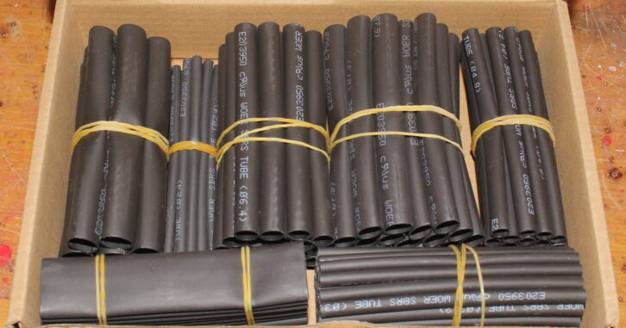The shrink comes in a variety of sizes.

Wayne recommends double-walled heat-shrink tubing. This type of heat shrink includes an inner lining of hot melt glue with excellent bonding properties. The shrinkage ratio is better than two times (closer to three times) the initial diameter, and the hot melt glue completely seals the tubing at both ends.

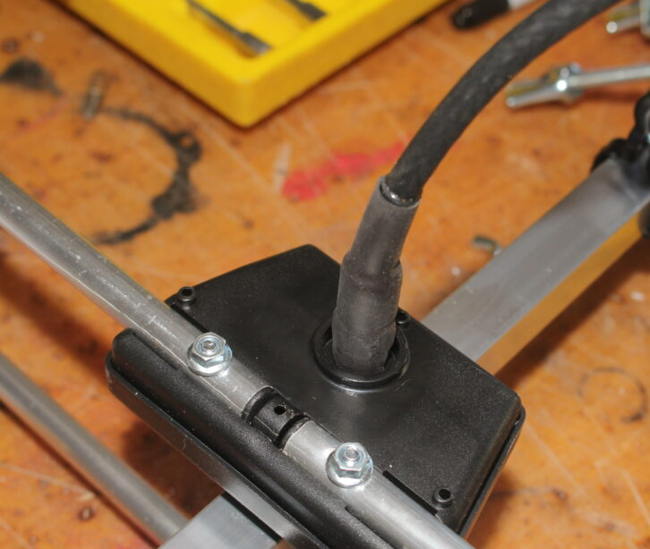Sealing the F-connector terminal on an antenna.

The seal is moisture-proof and splash-proof. In the accompanying photos you can see that a bit of the inner liner glue has migrated out of the ends as the tubing shrunk, creating a hermetic seal around the F connector.

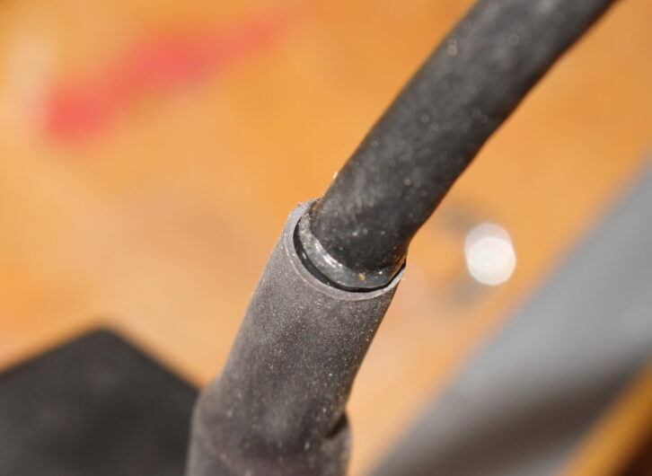Observe the end seal after the tubing is shrunk.

Should it become necessary to access the connector, you can lash the tubing with a box cutter and pull it free of the connector or splice. That’s not an option when you’re working with mastic.

Wayne obtains his kits from [www.mpja.com](http://www.mpja.com/), where the stock number is 38443 HS. An assortment of 140 pieces of double-walled heat shrink in various sizes is only $11.